# Test SQA Automation

# Rules :

Soal diberikan ke kandidat SQA Automation

Kandidat pilih soal 1 / 2

Waktu pengerjaan : 2 jam

Jawaban : zip / github dikirim ke email RTO

RTO kirim ke [juaracodingbootcamp@gmail.com](mailto:juaracodingbootcamp@gmail.com)

Subject email : Test SQA – Nomor Soal – nama kandidat

# Soal Test 1

1. Buatlah testcase menggunakan **cucumber** untuk menguji apakah teks yang dimasukan merupakan palindrome atau bukan.
2. Buatlah automation test menggunakan **UIPath** dari step caseberikut:  
   Case 1: buka tokped

Case 2: cari produk

Case 3: Klik whistlist produk (sudah dalam keadaan login)

1. Buatlah sebuah program dari **Selenium Web Driver** untuk mencari berapa jumlah produk yang tersedia setelah melakukan pencarian dan scrolling halaman dari website tokopedia.

# Soal Test 2

**Traveloka Quality Assurance**

**Take Home Test**

1. Please create **a Test Case** for *Traveloka Car Rental Search* form
2. There is a product that has several requirements for booking, the event booking is only open at certain hours (for example at 8-9 pm) by gathering several people who want to book a product. One of the requirements is that the price will be cheaper when there are 100 people on the booking channel. However, there is a bug on the page that informs us that the new product can be booked when there are 100 people.   
   **How to confirm the validity of the bugs? Please create the bugs report.**
3. 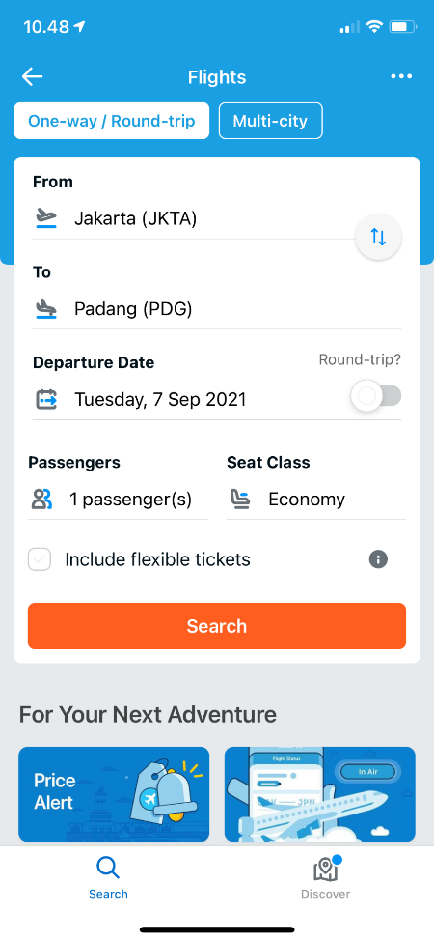Please create test automation from the following case studies and then integrate with Cucumber (BDD):

Jawab:

1. 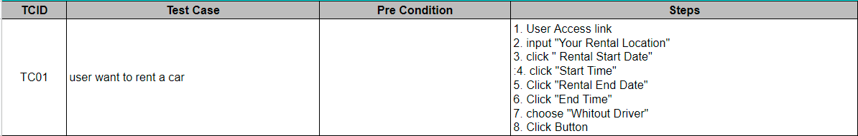

Lanjutan

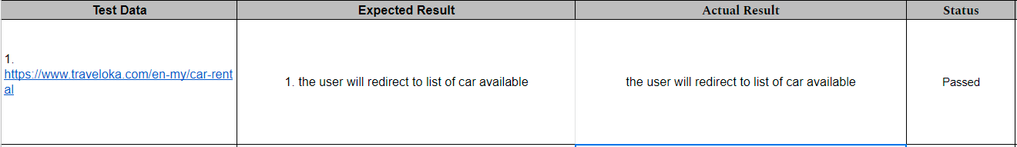

1. The bug could be validated using various input:

the booking is passed when:

* + - 1. More than 100 people
      2. At 8-9 pm
      3. Price cheaper when 100 people book

the booking is failed when:

Less than 100 people

Before or after 8-9pm

Price is fix when not enough people book.